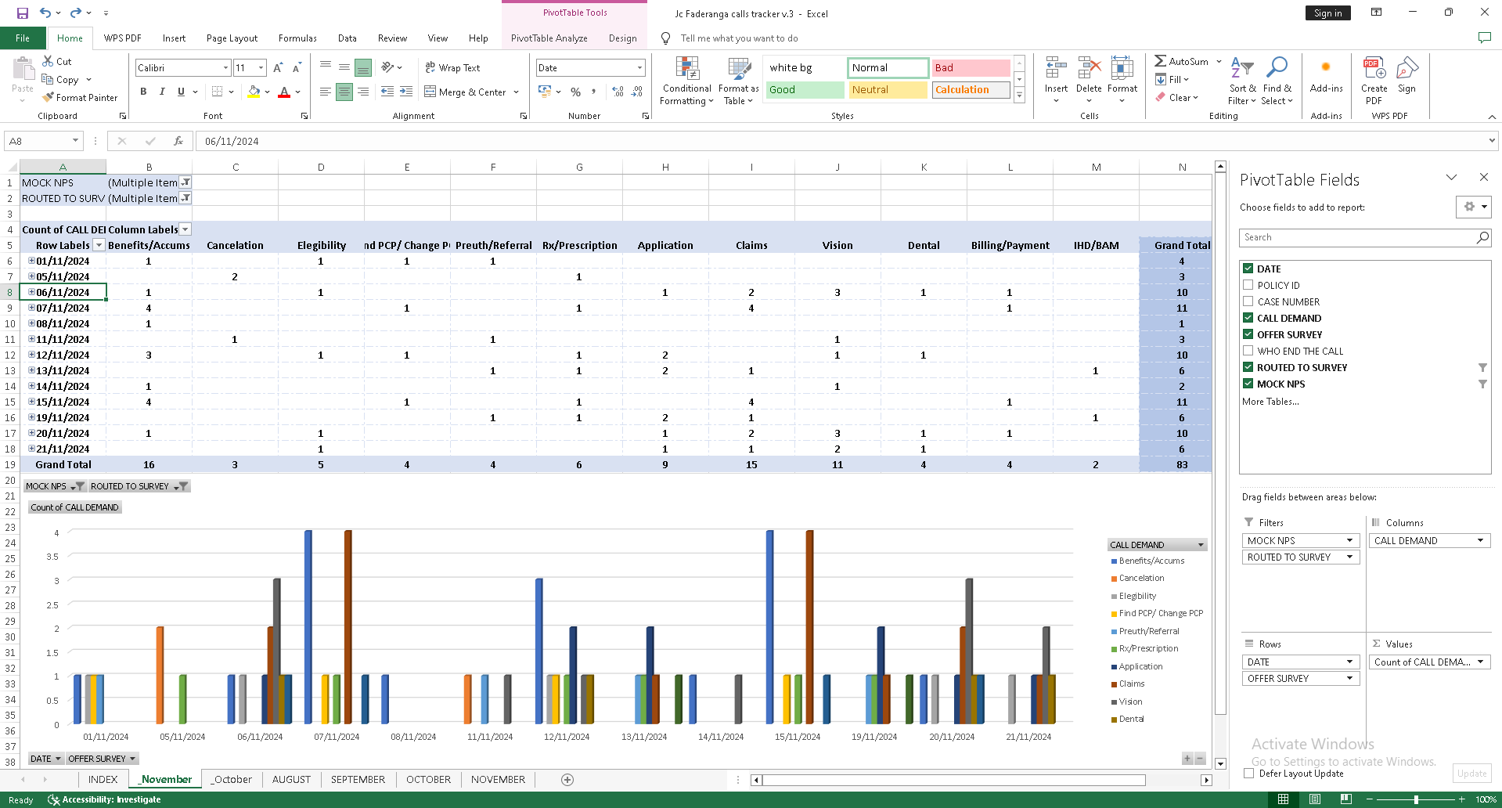

**PIVOT TABLE**

In the month of November, **Benefits/Accums** emerged as the highest call demand, receiving a total of 16 calls. This indicates that most callers were seeking information about their insurance benefits or coverage details.

**Claims** ranked second with 15 calls, highlighting that a significant portion of inquiries pertained to medical claims and their resolution.

On the other hand, **Vision** had the lowest call demand, with only 2 calls recorded. This suggests that fewer callers had concerns or inquiries related to vision-related insurance coverage or services.

Other notable categories include **Application** with 9 calls, and **Rx/Prescription** with 6 calls, showing moderate demand in these areas. These trends provide valuable insights into the primary concerns and priorities of callers during the given period.